Purpose of the review
West Dunbartonshire Council is reviewing its Scheme for the Establishment of Community Councils in accordance with the Local Government (Scotland) Act 1973. The proposals remain in draft and will be subject to final officer review, statutory consultation and consideration through the appropriate Council decision-making process.
Community Councils remain an important part of local democracy. They provide a recognised route for citizens to express local views, influence public bodies and contribute to community-led action. Experience under the current Scheme has, however, shown that the existing structure of 17 Community Council areas has been difficult to sustain. A number of areas are inactive, while others have experienced continuing difficulties with recruitment, office bearer roles, governance and engagement beyond those who regularly attend meetings.
The review is therefore intended to create a more sustainable, modern and practical framework that supports representative Community Councils across West Dunbartonshire, while retaining local identity and clear links between Community Councils, the Council, elected members, Community Planning Partners and local organisations.

Proposed structure and membership
The draft Scheme proposes replacing the current 17-area structure with nine Community Council areas: Dumbarton; Renton; Alexandria; Bonhill and Dalmonach; Balloch and Haldane; Kilmaronock; The Three Villages; Kilpatrick; and Clydebank Central & Waterfront. The proposed boundary map is included as Appendix 1.
The membership calculation has also been revised. Each area starts with a base figure of seven Community Councillor places, with one additional place added for each complete 3,000 people in the area. The base figure of seven is used to calculate the maximum membership and is not a fixed minimum. The minimum membership is one half of the resulting maximum, rounded up where the calculation is not a whole number. This ensures that the minimum is never below half of the approved maximum.
Across the nine proposed areas, the model provides a combined maximum of 90 Community Councillors and a combined minimum of 49. The detailed population and membership figures are included as Appendix 2.
Key figures
Measure | Current Scheme | Proposed Scheme
Community Council areas | 17 | 9
Combined minimum membership | 119 | 49
Combined maximum membership | 198 | 90

How the revised Scheme would operate
Community Councils would continue to be independent voluntary bodies whose central purpose is to ascertain, co-ordinate and express the views of the communities they represent. The revised Scheme places greater emphasis on demonstrating that positions reflect wider community views rather than only the views of members or people attending a meeting. Community Councils would be expected to engage citizens regularly, work with local groups, businesses and public bodies, and make particular efforts to involve young people and people who may experience barriers to participation.
The larger proposed areas require a balanced approach to meetings and engagement. Formal meetings should normally take place in a central, accessible location that citizens can identify and reach consistently. This should be supported by online or hybrid access where practical, local engagement sessions, surveys, community focused agenda items and outreach activity across the wider Community Council area. This approach allows a Community Council to operate as one accountable body while still recognising the different communities within its boundary.
Community Councils would also be encouraged to contribute to community-led action planning, Local Place Plans, locality planning, regeneration and other place-based work where this is relevant. These processes have different purposes and legal standing, and the Handbook will provide practical guidance on how Community Councils can contribute without taking on responsibilities that belong to the Council or other statutory partners.

Governance, support and training
The Scheme will be supported by a revised Community Council Handbook, Model Constitution, Standing Orders, Code of Conduct, Complaints Procedure and finance guidance. Together, these documents are intended to provide clearer and more consistent arrangements for elections, membership, meetings, public participation, financial controls, conduct, complaints and the relationship between Community Councils and West Dunbartonshire Council.
The Council will seek to provide clearer contact and escalation routes, while recognising that Community Councils remain responsible for their own meetings, records, correspondence, finances and internal governance. The Community Council Forum will continue to provide a collective voice, encourage peer learning and support dialogue on issues affecting more than one area. The distinct but complementary roles of Community Councillors, elected members and Council officers will be reflected in the guidance and training programme.
Training and development will be an important part of implementation. Priority areas include chairing effective meetings, preparing agendas and accurate minutes, treasurer responsibilities and basic bookkeeping, committee roles and governance, community engagement, equality and accessibility, data protection, digital communication, conflict management and complaints handling. The programme should be practical and proportionate, recognising that Community Councillors are volunteers with different levels of experience.
Consultation and implementation
The draft Scheme has been informed by online and in-person engagement, questionnaire feedback, discussions with Community Councils and the Community Council Forum, contributions from community organisations and Council officers, and relevant national legislation and guidance. The accompanying Community Engagement Report explains the evidence gathered, the main themes raised and how these have influenced the developing proposals.
If the Scheme is approved, detailed transitional arrangements will be required to move from the current 17 areas to the revised nine-area structure. This will include elections under the new boundaries, transfer or closure of bank accounts and records, final accounts, assets, insurance, live planning and consultation matters, email and social media accounts, and practical handover to the newly established Community Councils. Supporting guidance and training will be issued to help minimise disruption and provide a clear basis for the new arrangements.
Overall, the proposed Scheme is intended to provide a more sustainable, practical and accountable basis for Community Councils across West Dunbartonshire. It combines a revised boundary and membership structure with clearer governance, stronger community engagement and a more structured approach to support and development.

Appendix 1
Proposed Community Council Areas
The map below shows the nine proposed Community Council areas considered as part of the 2026 review. The boundaries remain subject to the statutory consultation and Council approval process.

Source: West Dunbartonshire Council boundary review mapping, June 2026. Ordnance Survey copyright is shown on the map.
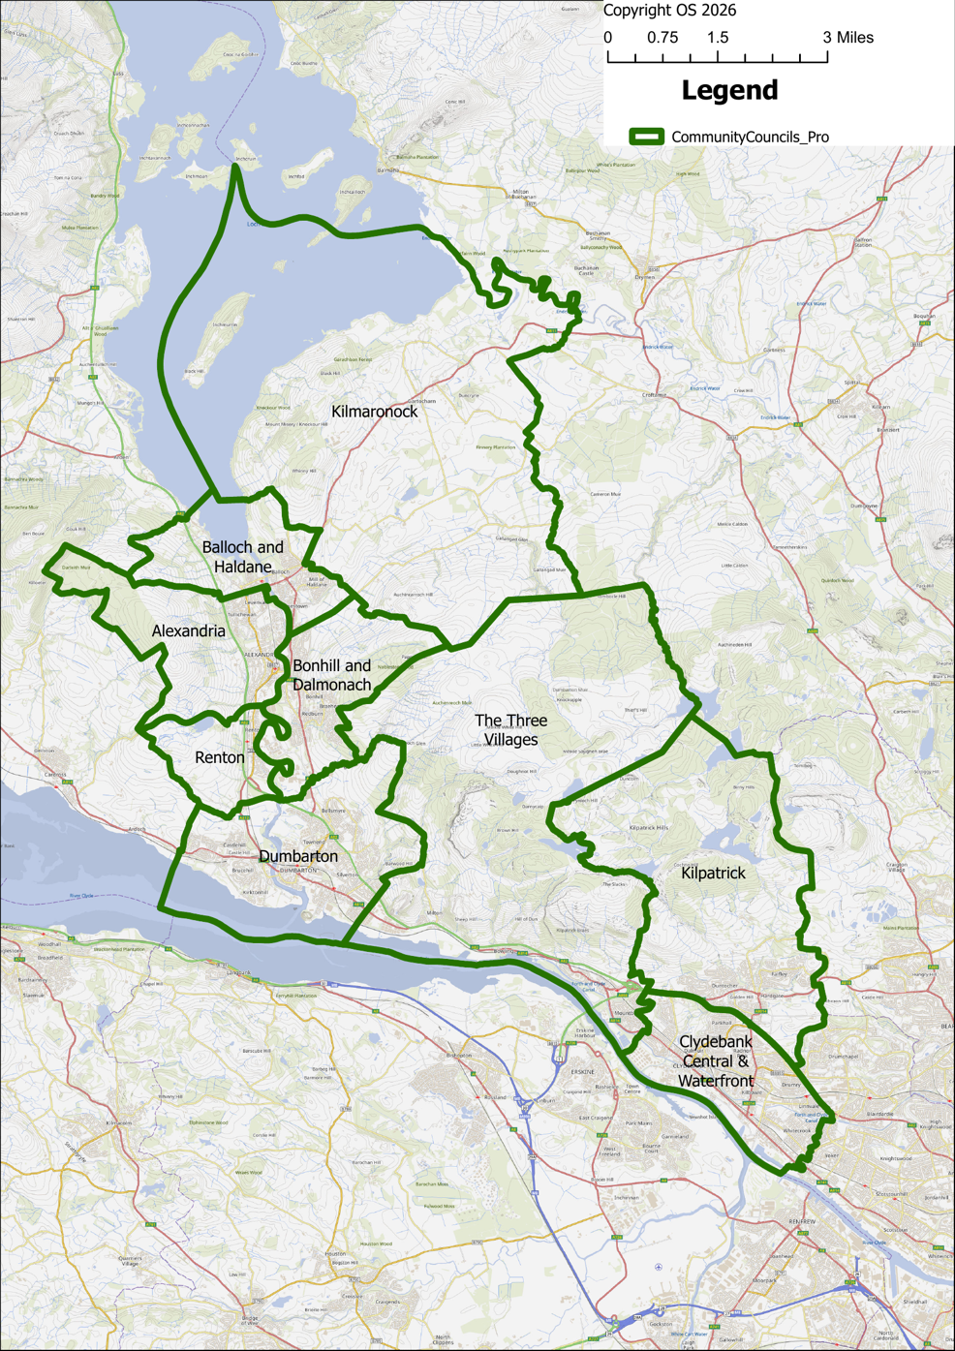

Appendix 2
Community Council Composition
The table sets out the population, base figure, minimum membership and maximum membership for each proposed Community Council area. The minimum figures are rounded up where half of the maximum is not a whole number.
Community Council area | Population | Base number | Minimum number | Maximum number
Dumbarton | 19,752 | 7 | 7 | 13
Renton | 2,207 | 7 | 4 | 7
Alexandria | 7,041 | 7 | 5 | 9
Bonhill and Dalmonach | 9,062 | 7 | 5 | 10
Balloch and Haldane | 6,041 | 7 | 5 | 9
Kilmaronock | 744 | 7 | 4 | 7
The Three Villages | 6,068 | 7 | 5 | 9
Kilpatrick (Clydebank North) | 12,467 | 7 | 6 | 11
Clydebank Central & Waterfront (Clydebank South) | 26,978 | 7 | 8 | 15
TOTAL |  | 63 | 49 | 90
Membership formula

Element | Calculation
Maximum membership | A base of seven Community Councillors, plus one additional place for each complete 3,000 people in the Community Council area. Any incomplete block of 3,000 is disregarded.
Minimum membership | One half of the maximum membership, rounded up to the nearest whole number where necessary.
Worked example | A maximum of 9 produces a minimum of 5. A maximum of 10 produces a minimum of 5.
Population figures are those used for the 2026 review of the Scheme for the Establishment of Community Councils.

